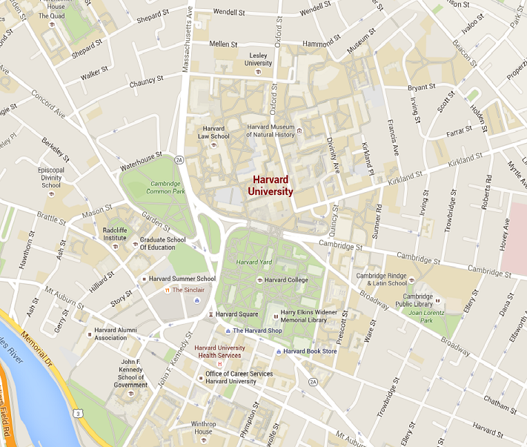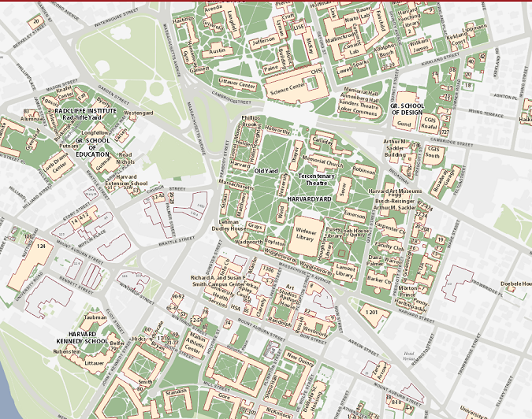Oscar Keur, 11122102

*Which map promotes an easier visual search for buildings?*

Obviously the Harvard map. (right) There is almost no contrast between the colour of university grounds and buildings in google maps, while Harvard uses extra contrast by adding a red accent

*Which map more effectively visualizes routes from a random point A to point B?*

Routevisualization is better on google maps, because the white color is only used for roads in google maps, by which you can fast recognize patterns based on the unique status of the color white in the map. The hardvard map has the same problems with roads as google maps has with buildings: the contrast is too low by which it is very hard to distinguish one from the other.

Which map is an overall better visualization, and why?

Google Maps is better because it is adaptive. The aforementioned lack in contrast for buildings is changed when you zoom in. So it shows only an overview in the start and gives detailed information once you ‘ask ‘ for it. The Harvard map is static and only works on the showed scale, when you zoom out, names overlap and because buildings are persistently drawn on map they are not distinguishable anymore.

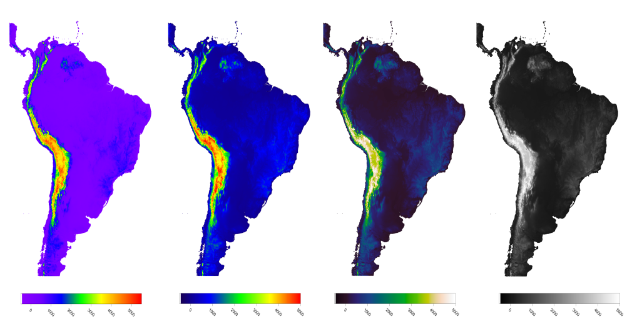

https://mycarta.wordpress.com/2012/12/06/the-rainbow-is-deadlong-live-the-rainbow-part-5-cie-lab-linear-l-rainbow/

In context the intended objective here is to demonstrate the use of other colorschemes. On itself it could be a visualization aimed at explaining the differences in climates in South America, aimed at students. It does convey the information, but it also misleads. On the other shown maps in other colorschemes, there is less to be seen in the Andes, while the rainbowmap suggests lots of information to be found here. Also the mountains in brazil are not clearly visible, so it does fail to convey this, while these are clearly visible on the other 3 maps. (but this was not the intended use I came up with). In the situation a rainbow color map would only be appropriate when the intended use is to demonstrate some difference in temperatures. Otherwise i would use the third colormap shown. This has the most detail, without misleading the viewer.